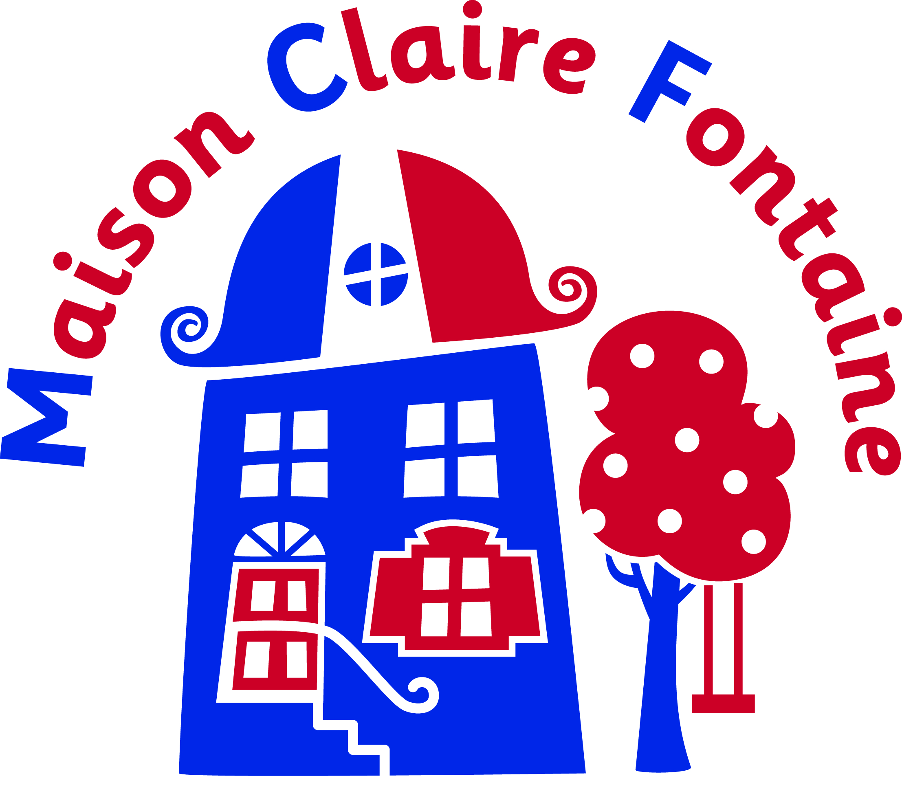

Medical Consent for School Visit to Maison Claire Fontaine

School name : Dates of trip :

Child’s name : Date of birth :

Home Address :

Telephone number in case of emergency during the trip :

Name of child’s doctor :

Doctor’s Address :

Doctor’s telephone number :

Medical Information (if you answer YES to any of the first 3 questions please give further details on the next page) :

- Does your son / daughter have any conditions requiring medical treatment, including medication ? YES/NO

- To the best of your knowledge, has your son/daughter been in contact with any contagious or infectious diseases or suffered from anything in the last four weeks that may be contagious or infectious ? YES / NO

- Is your son/daughter allergic to any medication ? YES / NO

- When did your son/daughter last have a tetanus injection ?

- Please outline the type of pain / flu relief medication your son/daughter may be given if necessary.

If you have answered YES to any of the previous questions, please give details below together with any additional information you feel would be useful to us. Please note that arrangements must be made by the parent to provide suitable bedding if bed wetting is a potential concern.

Dietary Information (Please outline any special dietary requirements for your son/ daughter):

I hereby give permission for my child to receive proprietary medications and all necessary medical treatment, including anaesthetic or blood transfusion in the case of an emergency. I declare that I have answered all the above questions to the best of my ability and have not knowingly withheld any information regarding physical fitness. I will inform the group leader as soon as possible of any changes in the medical or other circumstances between now and the commencement of the journey.

Signed : Date :

Full name (capitals) :

