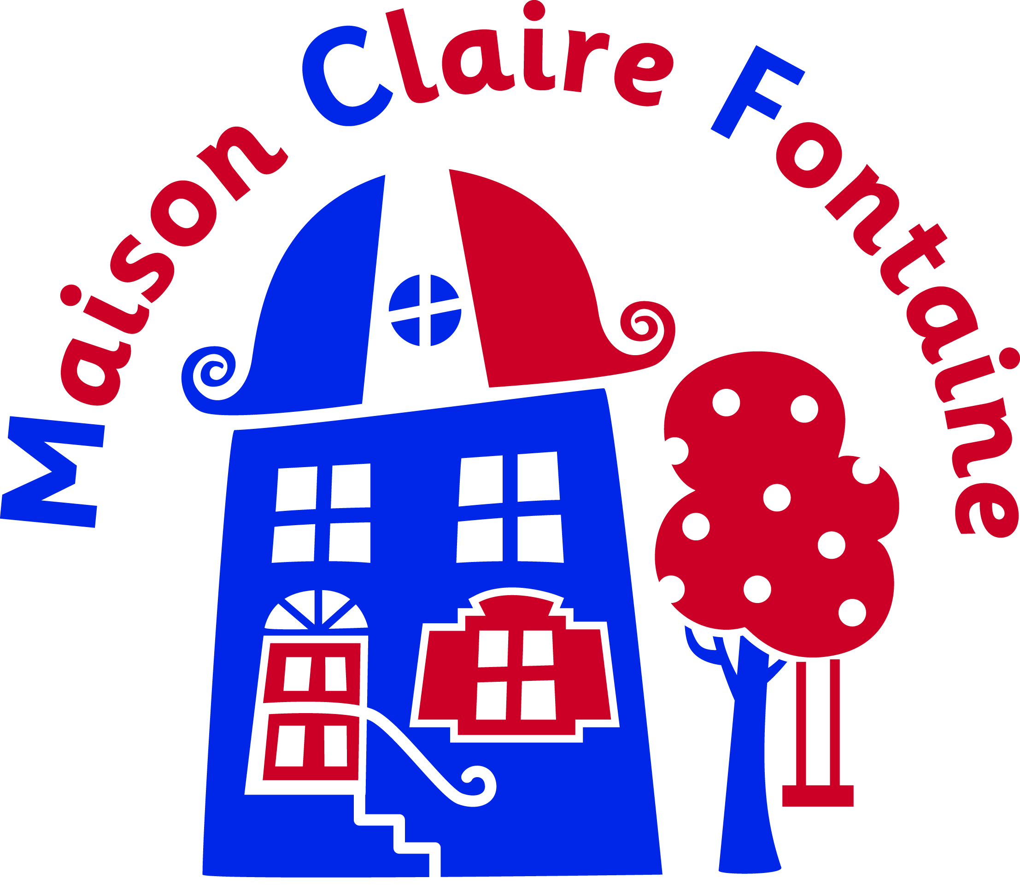

Consent form for Canöe-Kayak
(To completed by parent or guardian)

School name :

Child’s name :

SWIMMING ABILITY

- Is your son / daughter able to swim 25 metres? YES/NO

- Is your son / daughter water confident in the pool? YES/NO

- Is your son / daughter nervous about going on a lake or river ? YES/NO

- Does your son / daughter have any medical or special needs condition that could affect them taking part in this activity ? YES /NO

If necessary – please give details below :

I give permission for my son / daughter to take part in the canöe-kayak activity during the French trip to Maison Claire Fontaine. I confirm that I consider him/her fit to participate.

Signed : Date :

Full name (capitals) :

