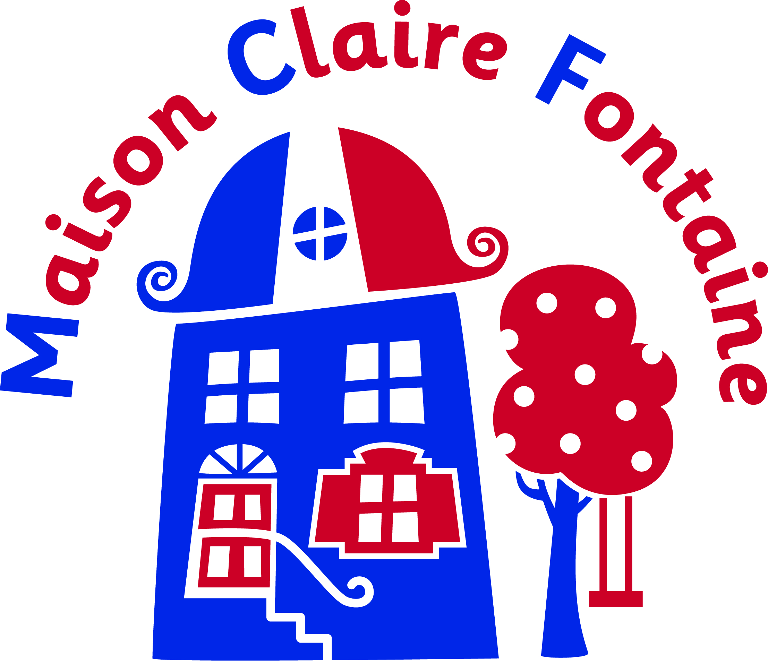

Consent form for Tree Adventure Activity

(To completed by parent or guardian)

I would like…………………………………………….. (name) to take part in the Tree adventure activity during the French trip to Maison Claire Fontaine

Birth date (month/day/year) ____/____/______

Age during activity _______

Declaration of consent:

- I agree to my son / daughter taking part in the tree adventure activity and, agree to his/her participation. I acknowledge the need to listen carefully to directions and responsible behaviour on his/her part. I acknowledge that if my son / daughter does not behave appropriately s/he will not take part in the activity.

- I agree that my son / daughter is fit to participate in this activity and if it becomes necessary for my child to receive emergency medical or dental treatment and I cannot be reached by telephone, I hereby authorise the treatment.

- I expressly agree and promise to inform my child of the risks existing in the tree adventure activity. My son / daughter’s participation in tree activity programs is purely voluntary, and I elect to allow him/her to participate in spite of the risks. I accept the risks involved in participating in the tree adventure activity and I will not be seeking out the responsibilities of staff should any accident occur because of those risks or by acts of God.

Signed…………………………………….…………… Date…………………………………….

Full name of parent /guardian …………………………………………

